Encontré información de este bug en:

Bug #1682193 “Mouse acceleration significantly reduced after upg...” : Bugs : xorg package : Ubuntu
https://bugs.launchpad.net/ubuntu/+source/xorg/+bug/1682193

How to disable mouse acceleration in Ubuntu 16.04 - Ask Ubuntu
https://askubuntu.com/questions/794185/how-to-disable-mouse-acceleration-in-ubuntu-16-04

Debo poner en la terminal:

xinput --list

Obtengo:

wachin@Dell-Inspiron-1750:~$ xinput --list
⎡ Virtual core pointer id=2 [master pointer (3)]
⎜ ↳ Virtual core XTEST pointer id=4 [slave pointer (2)]
⎜ ↳ Logitech K400 id=10 [slave pointer (2)]
⎜ ↳ SynPS/2 Synaptics TouchPad id=12 [slave pointer (2)]
⎣ Virtual core keyboard id=3 [master keyboard (2)]
↳ Virtual core XTEST keyboard id=5 [slave keyboard (3)]
↳ Video Bus id=6 [slave keyboard (3)]
↳ Power Button id=7 [slave keyboard (3)]
↳ Sleep Button id=8 [slave keyboard (3)]
↳ Integrated_Webcam_1.3M id=9 [slave keyboard (3)]
↳ AT Translated Set 2 keyboard id=11 [slave keyboard (3)]
↳ Dell WMI hotkeys id=13 [slave keyboard (3)]
↳ Logitech K400 id=14 [slave keyboard (3)]

Luego como he obtenido el id=14 debo poner:

xinput list-props 10

Nota: No confundir con “Virtual core keyboard” esos son otros valores. Para el Touchpad de teclado Logitech K400 es "Virtual core pointer"

me sale:

wachin@Dell-Inspiron-1750:~$ xinput list-props 10
Device 'Logitech K400':
Device Enabled (137): 1
Coordinate Transformation Matrix (139): 1.000000, 0.000000, 0.000000, 0.000000, 1
.000000, 0.000000, 0.000000, 0.000000, 1.000000
libinput Accel Speed (274): 0.900000
libinput Accel Speed Default (275): 0.000000
libinput Accel Profiles Available (276): 1, 1
libinput Accel Profile Enabled (277): 1, 0
libinput Accel Profile Enabled Default (278): 1, 0
libinput Natural Scrolling Enabled (279): 0
libinput Natural Scrolling Enabled Default (280): 0
libinput Send Events Modes Available (259): 1, 0
libinput Send Events Mode Enabled (260): 0, 0
libinput Send Events Mode Enabled Default (261): 0, 0
libinput Left Handed Enabled (281): 0
libinput Left Handed Enabled Default (282): 0
libinput Scroll Methods Available (283): 0, 0, 1
libinput Scroll Method Enabled (284): 0, 0, 0
libinput Scroll Method Enabled Default (285): 0, 0, 0
libinput Button Scrolling Button (286): 2
libinput Button Scrolling Button Default (287): 2
libinput Middle Emulation Enabled (288): 0
libinput Middle Emulation Enabled Default (289): 0
Device Node (262): "/dev/input/event5"
Device Product ID (263): 1133, 16420
libinput Drag Lock Buttons (290): <no items>
libinput Horizontal Scroll Enabled (291): 1

Para aumentar la velocidad debo poner así:

xinput --set-prop "pointer:Logitech K400" "libinput Accel Speed" 1

o también sería con puro numero (los equivalentes en vez de las "") así:

xinput --set-prop 10 274 1

Nota: 1 es lo maximo que se puede poner.

Eso según la ayuda:

xinput --help

xinput set-prop <device> [--type=atom|float|int] [--format=8|16|32] <property> <val> [<val> ...]

Eso es más complicado pero según veo en los ejemplos de:

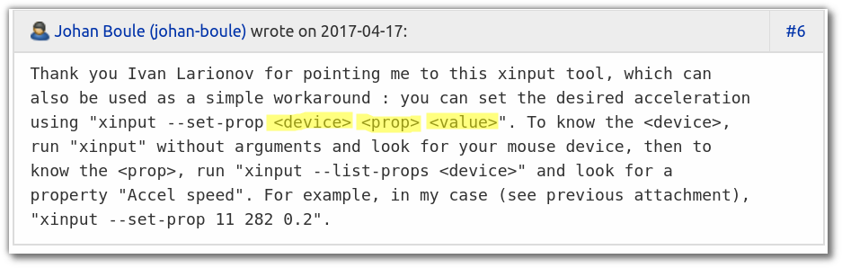
Bug #1683145 “Mouse pointer speed setting has no effect” : Bugs : unity-control-center package : Ubuntu
https://bugs.launchpad.net/ubuntu/+source/unity-control-center/+bug/1683145

pero también estoy viendo en:

x11 - How can I set mouse sensitivity, not just mouse acceleration? - Unix & Linux Stack Exchange
https://unix.stackexchange.com/questions/90572/how-can-i-set-mouse-sensitivity-not-just-mouse-acceleration

Allí explica que :

We want the «Coordinate Transformation Matrix», remember its №142.

By changing this property we can increase the pointer speed. It is a transformation matrix, used to calculate a pointer movement. From the link:

By default, the CTM for every input device in X is the identity matrix. As an example, lets say you touch a touchscreen at point (400, 197) on the screen:
⎡ 1 0 0 ⎤ ⎡ 400 ⎤ ⎡ 400 ⎤
⎜ 0 1 0 ⎥ · ⎜ 197 ⎥ = ⎜ 197 ⎥
⎣ 0 0 1 ⎦ ⎣ 1 ⎦ ⎣ 1 ⎦
The X and Y coordinates of the device event are input in the second matrix of the calculation. The result of the calculation is where the X and Y coordinates of the event are mapped to the screen. As shown, the identity matrix maps the device coordinates to the screen coordinates without any changes.
So, we want to increase the values according to x and y, thus increasing the pointer speed. An example from my PC:

$ xinput set-prop 10 142 2.400000, 0.000000, 0.000000, 0.000000, 2.400000, 0.000000, 0.000000, 0.000000, 1.000000
It is xinput set-prop <device-id> <property-number> <property-values>. Play a bit with this until you find the appropriate one. Note: do not change the last value of the matrix. That was my error when I tried it to get work — in this case you just won't see any difference.

Acknowledgements: I am grateful to Simon Thum from xorg mailing list, he was the one who gave the hint about the matrix.

UPD: note, some Windows games running with Wine may have odd pointer behavior (e.g. noticed, that the aim in old Counter Strike 1.6 declines down, until it stares the floor, no matter how you move the mouse), in this case just reset x and y of CTM to 1 before running the game.

Como para mi es:

xinput list-props 10

me sale:

Device 'Logitech K400':
Device Enabled (137): 1
Coordinate Transformation Matrix (139): 1.000000, 0.000000, 0.000000, 0.000000, 1
.000000, 0.000000, 0.000000, 0.000000, 1.000000
libinput Accel Speed (274): 0.900000
libinput Accel Speed Default (275): 0.000000

para Transformation Matrix

lo que me sale a mi:

Coordinate Transformation Matrix (139): 1.000000, 0.000000, 0.000000, 0.000000, 1.000000, 0.000000, 0.000000, 0.000000, 1.000000

De ellos:

Coordinate Transformation Matrix (142): 1.000000, 0.000000, 0.000000, 0.000000, 1.000000, 0.000000, 0.000000, 0.000000, 1.000000

El valor que puso el:

xinput set-prop 10 142 2.400000, 0.000000, 0.000000, 0.000000, 2.400000, 0.000000, 0.000000, 0.000000, 1.000000

el valor que debo poner yo:

xinput set-prop 10 139 2.400000, 0.000000, 0.000000, 0.000000, 2.400000, 0.000000, 0.000000, 0.000000, 1.000000

Ufff, hasta demasiado rápido.

Un poco más despacio:

xinput set-prop 10 139 2.000000, 0.000000, 0.000000, 0.000000, 2.000000, 0.000000, 0.000000, 0.000000, 1.000000

Un poco más despacio:

xinput set-prop 10 139 1.700000, 0.000000, 0.000000, 0.000000, 1.700000, 0.000000, 0.000000, 0.000000, 1.000000

Un poco más despacio:

xinput set-prop 10 139 1.300000, 0.000000, 0.000000, 0.000000, 1.300000, 0.000000, 0.000000, 0.000000, 1.000000

